Competitive Shooters of Lake Norman USPSA April 9th, 2026
COURSE DESIGNER: Ryan Christenson

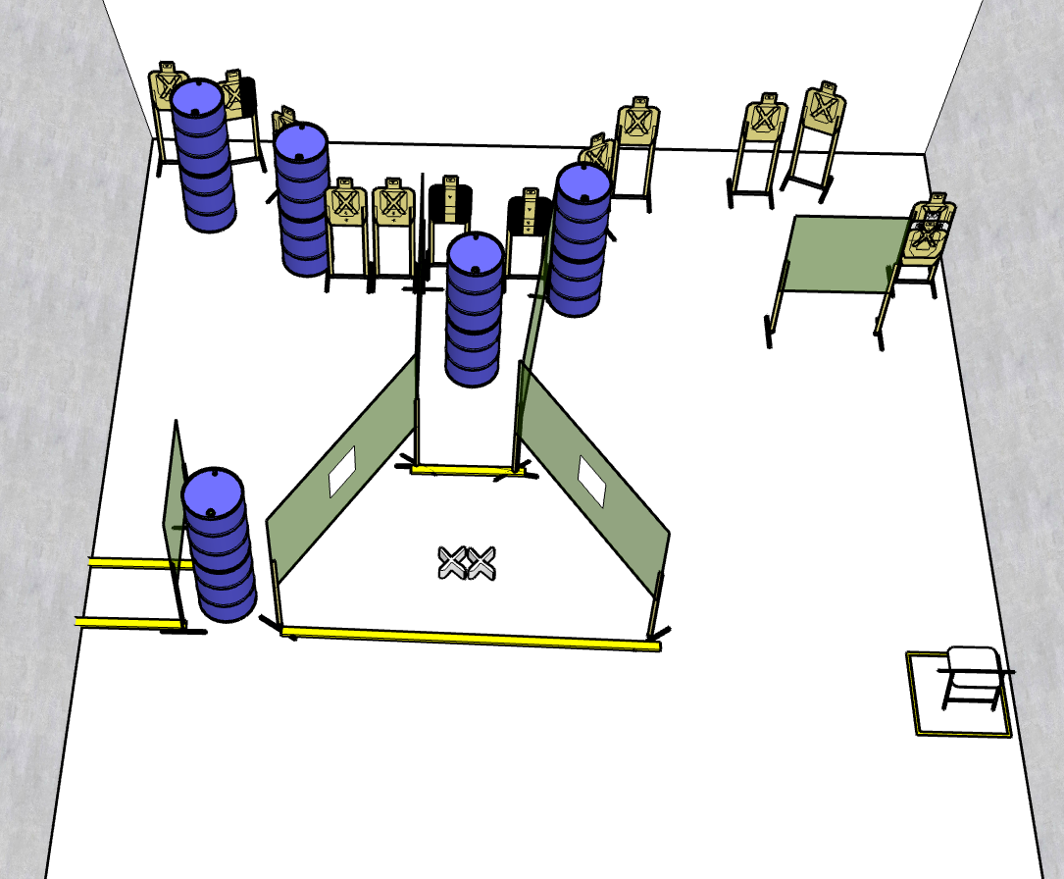

Stage 2 – Tony!
13 rounds, 65 points, Virginia count
There are 13 cardboard targets. Best 1 hit will score.
Starting with both feet on Red XXs.
Handgun is unloaded and holstered, wrists above head.
PCC is unloaded, stock touching belt, strong hand wrist above head.
On the audible start signal, engage targets from within the shooting area.

